**Assignment: 3**

**Problem Statement:** Create IAM user and give full access to S3.

The steps to create IAM user:-

Step 1: Select “IAM” option.

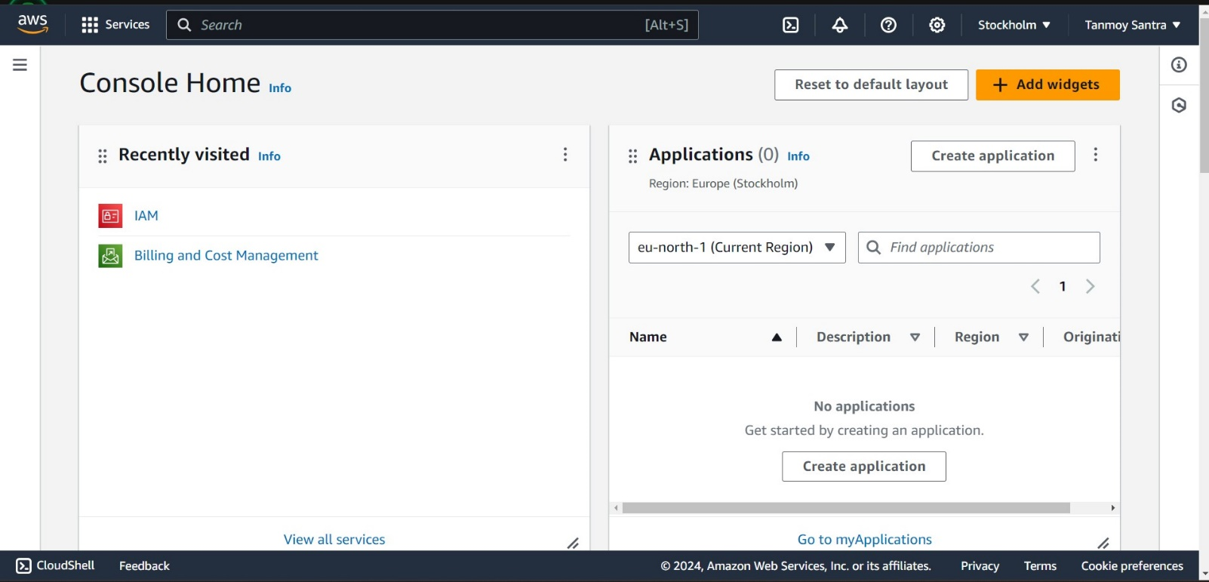

Step 2: Select “Users” option.

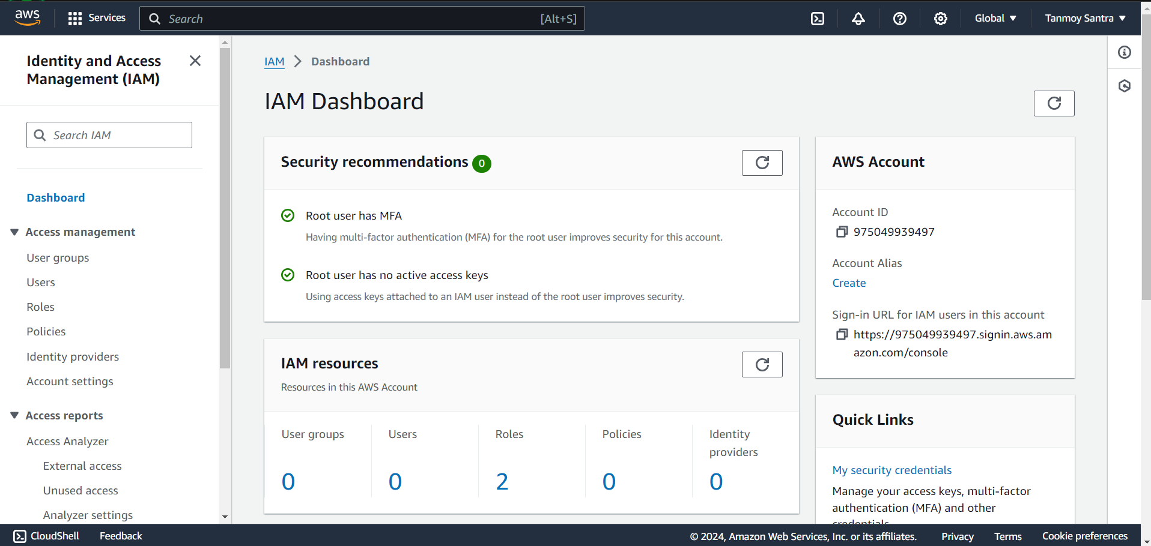

Step 3: Now click on “Create user” option.

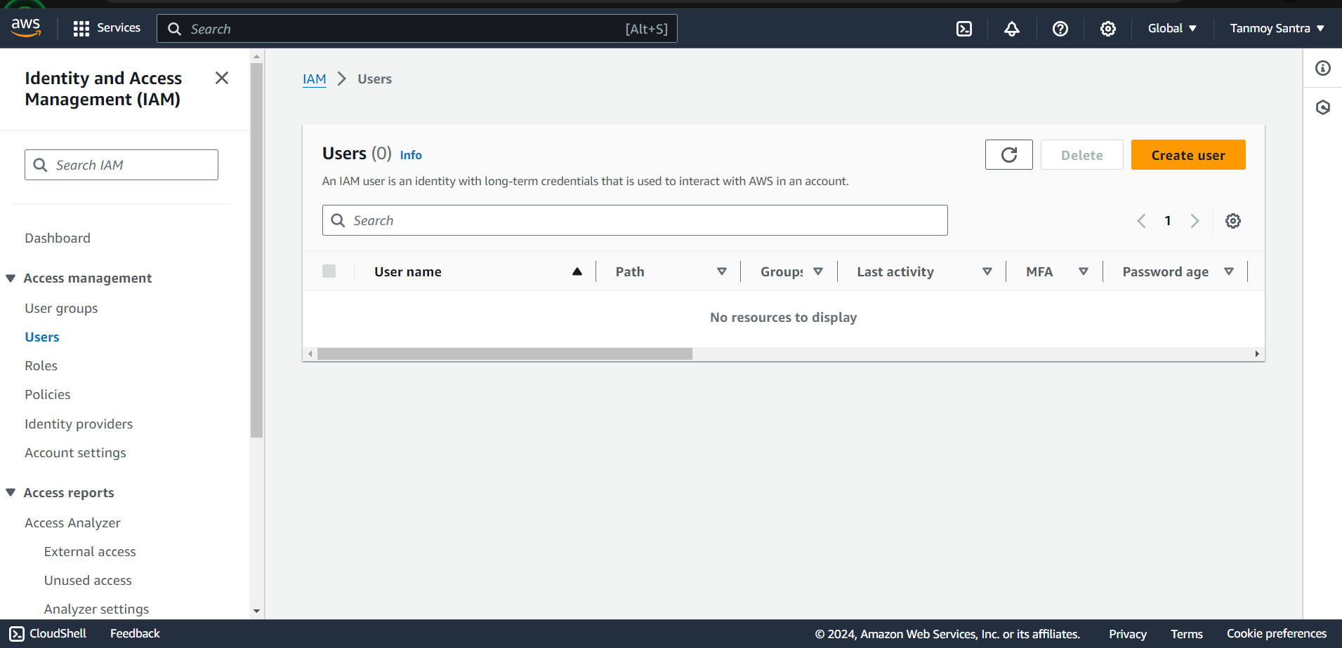

Step 4: Give username (‘s3_user’ in my case) then select the option “I want to create an IAM

user”, now set a custom password then “Next”.

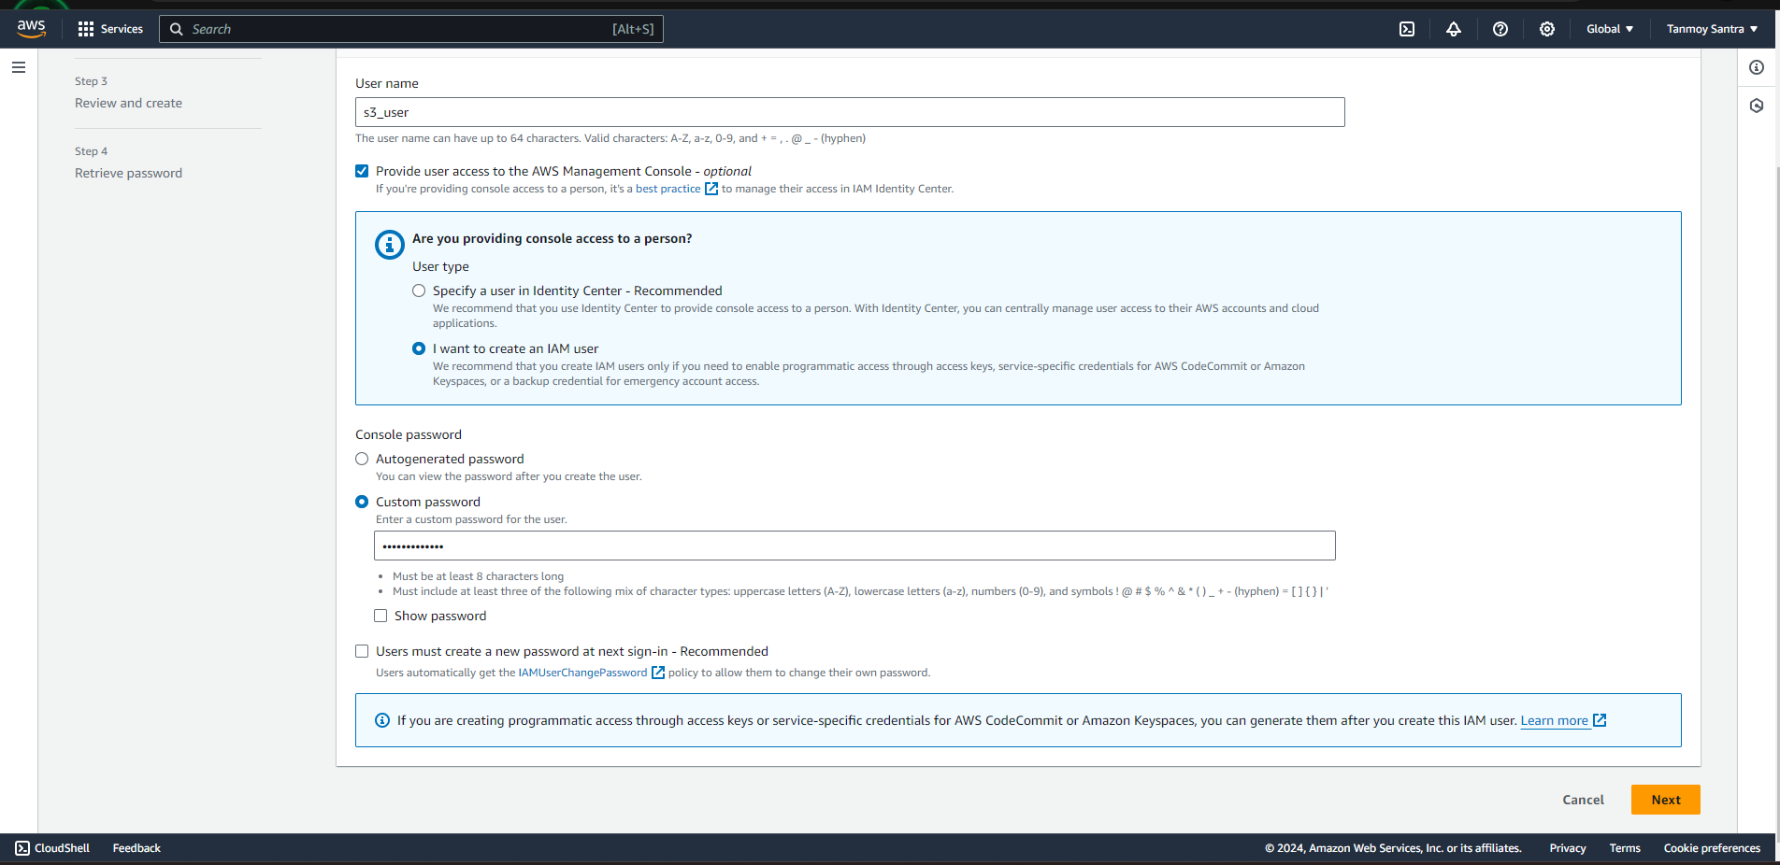

Step 5: Select on “Create group”.

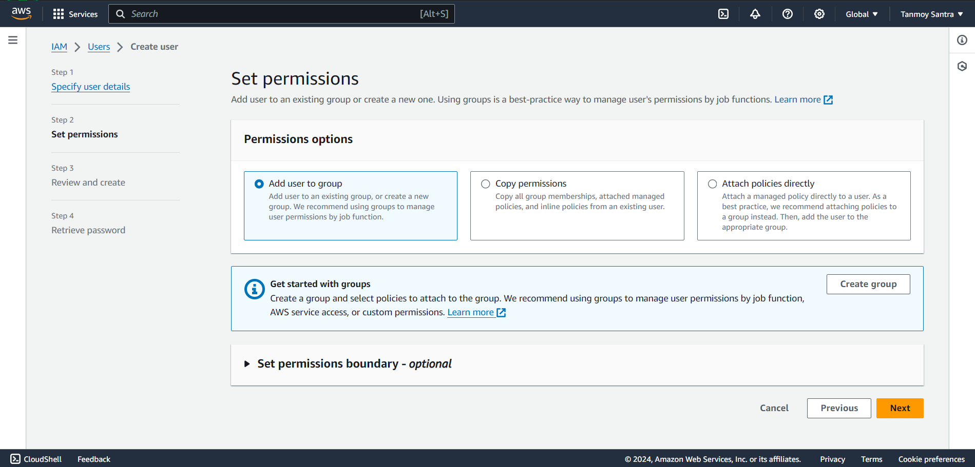

Step 6: Give a user group name then select S3 Full Access, now click on “Create user group”.

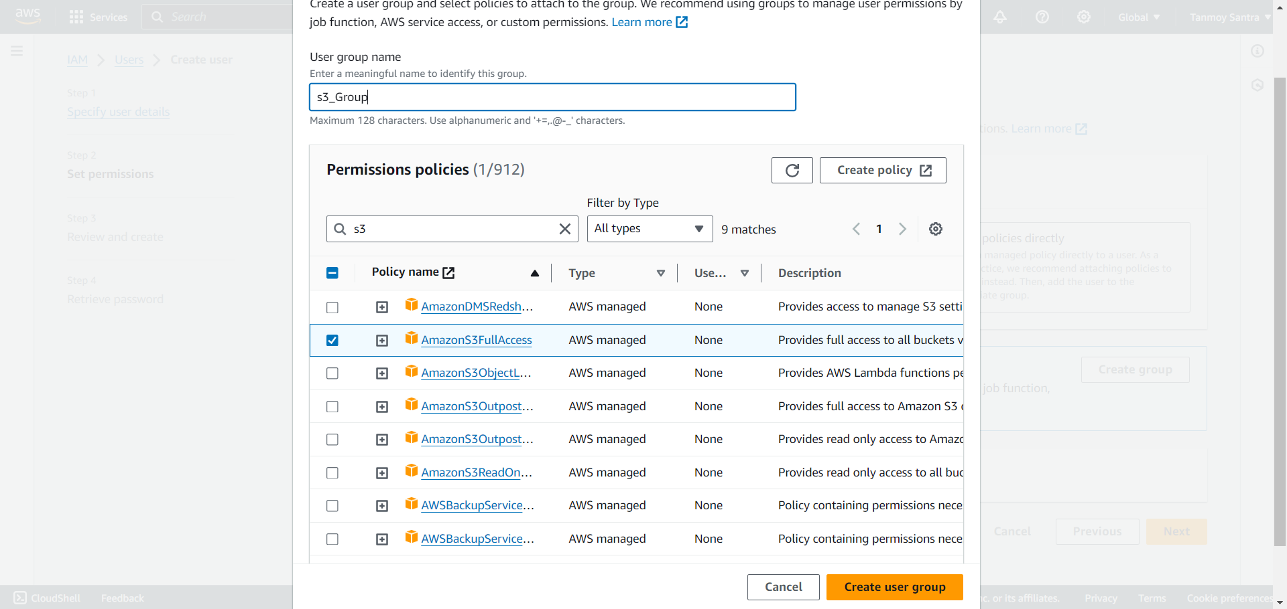

Step 7: Select the created group then click “Next”.



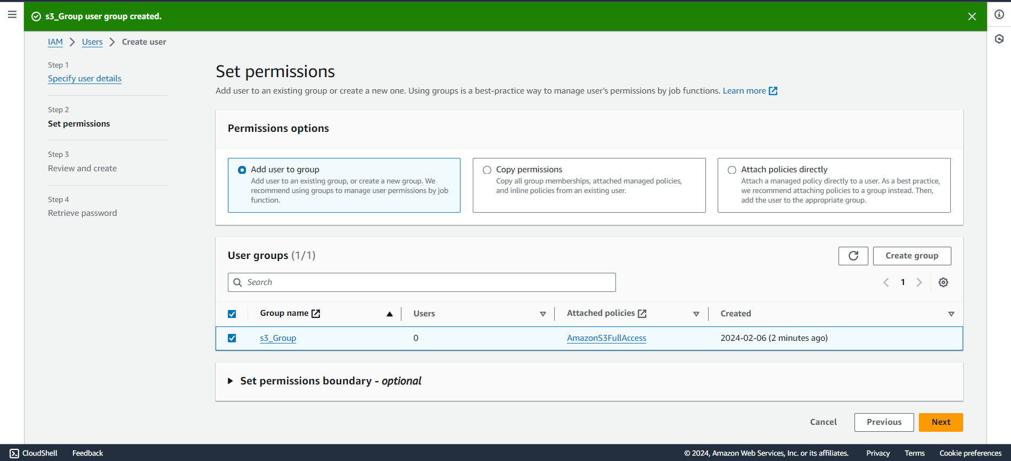

Step 8: Click upon “Create user”.

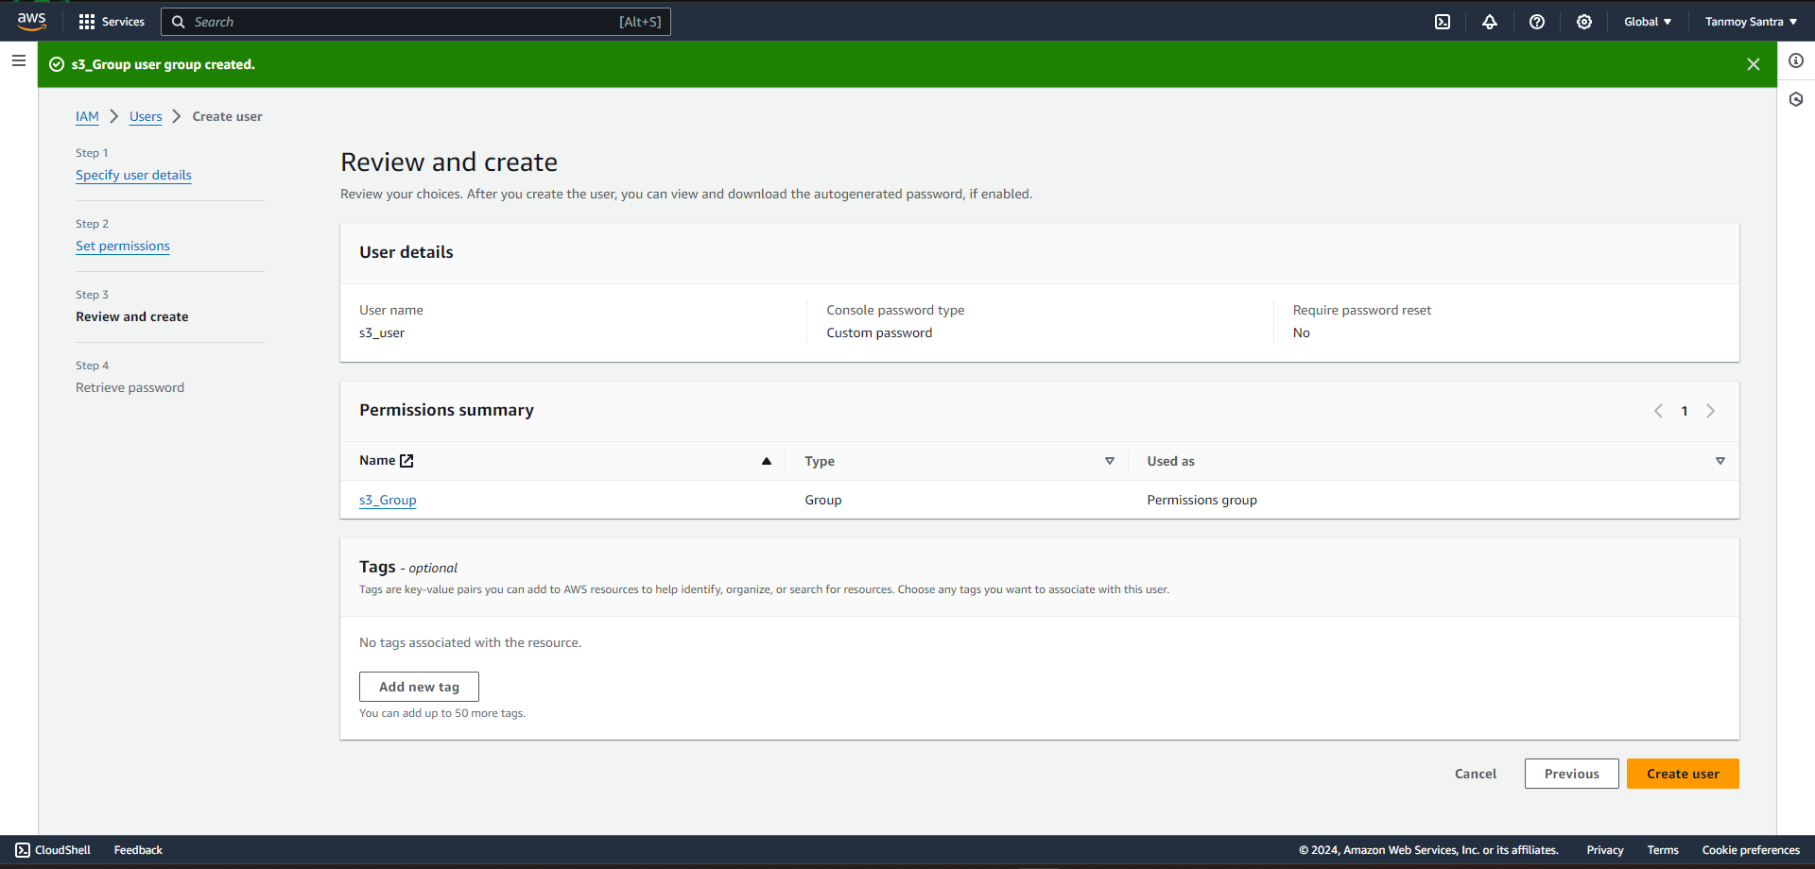

Step 9: Click upon “Return to users list”.

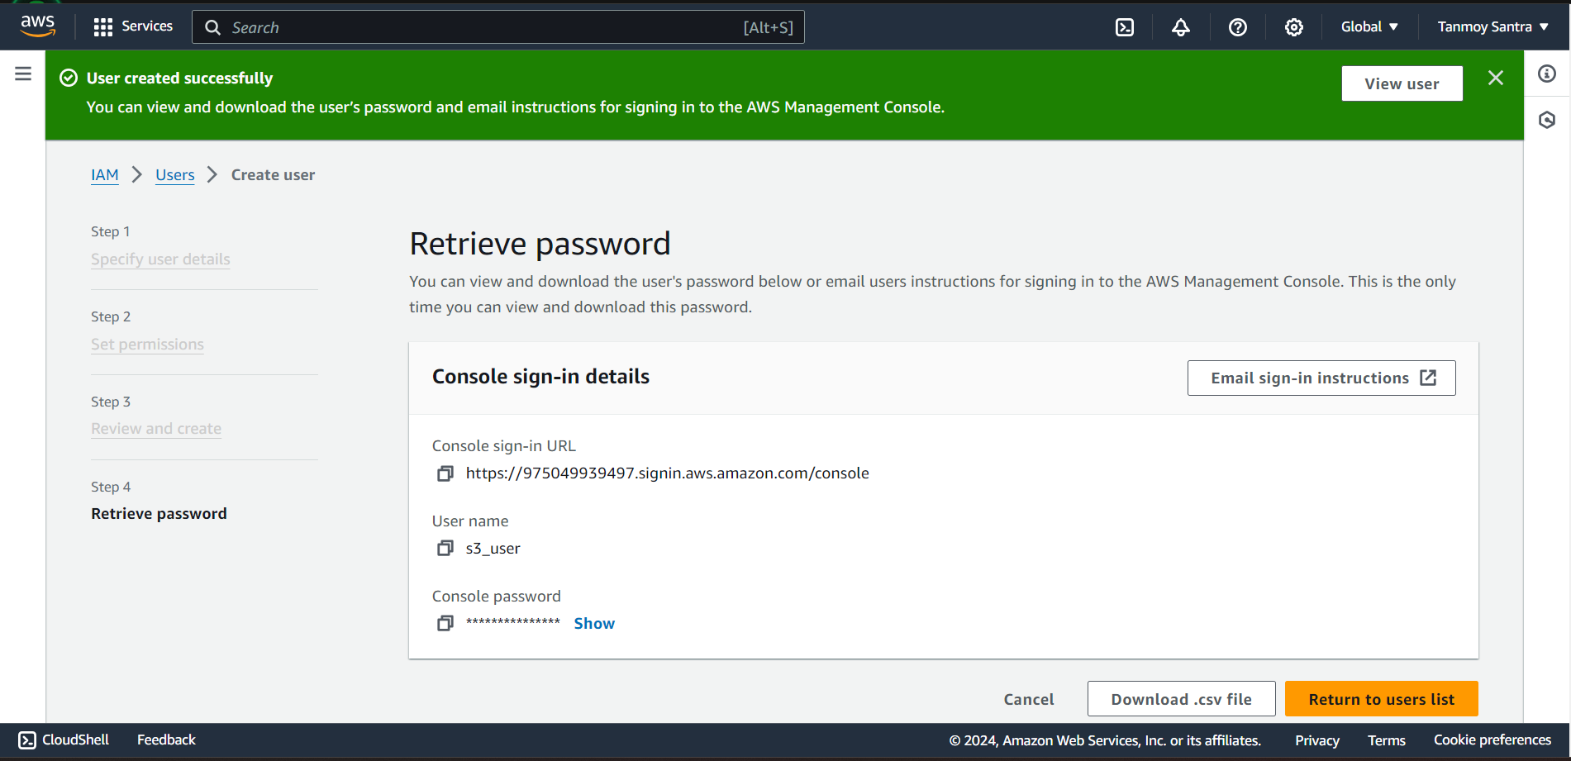

Step 10: User created successfully.

